We can draw 10 points for the group, and we can draw an edge between two points if the two people shook hands. I will label the points for Mr. and Mrs. Lars and then call the other couples A/A’, B/B’, C/C’, and D/D’.

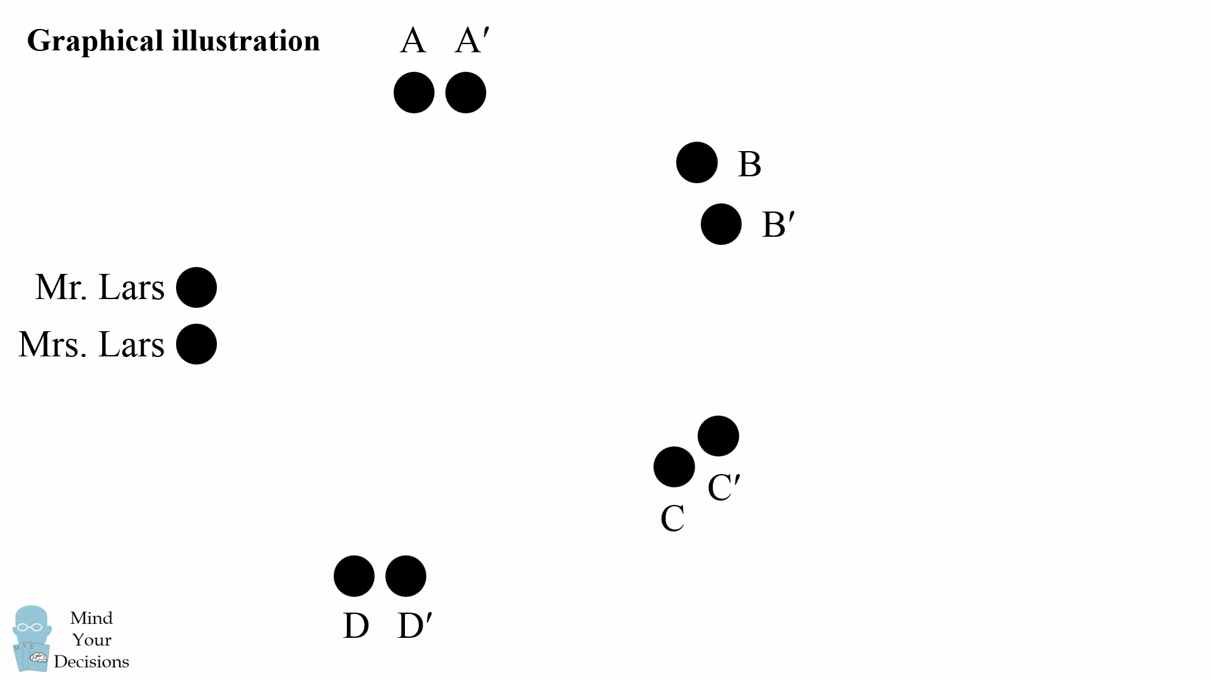

One person answered 8, meaning some point has 8 edges. For the same reason as the 1 couple case, this point cannot be Mrs. Lars (as that would mean else everyone would answer at least 1–but someone answered 0), so it has to be some other point that connects to everyone else in the group. Suppose that is person A.

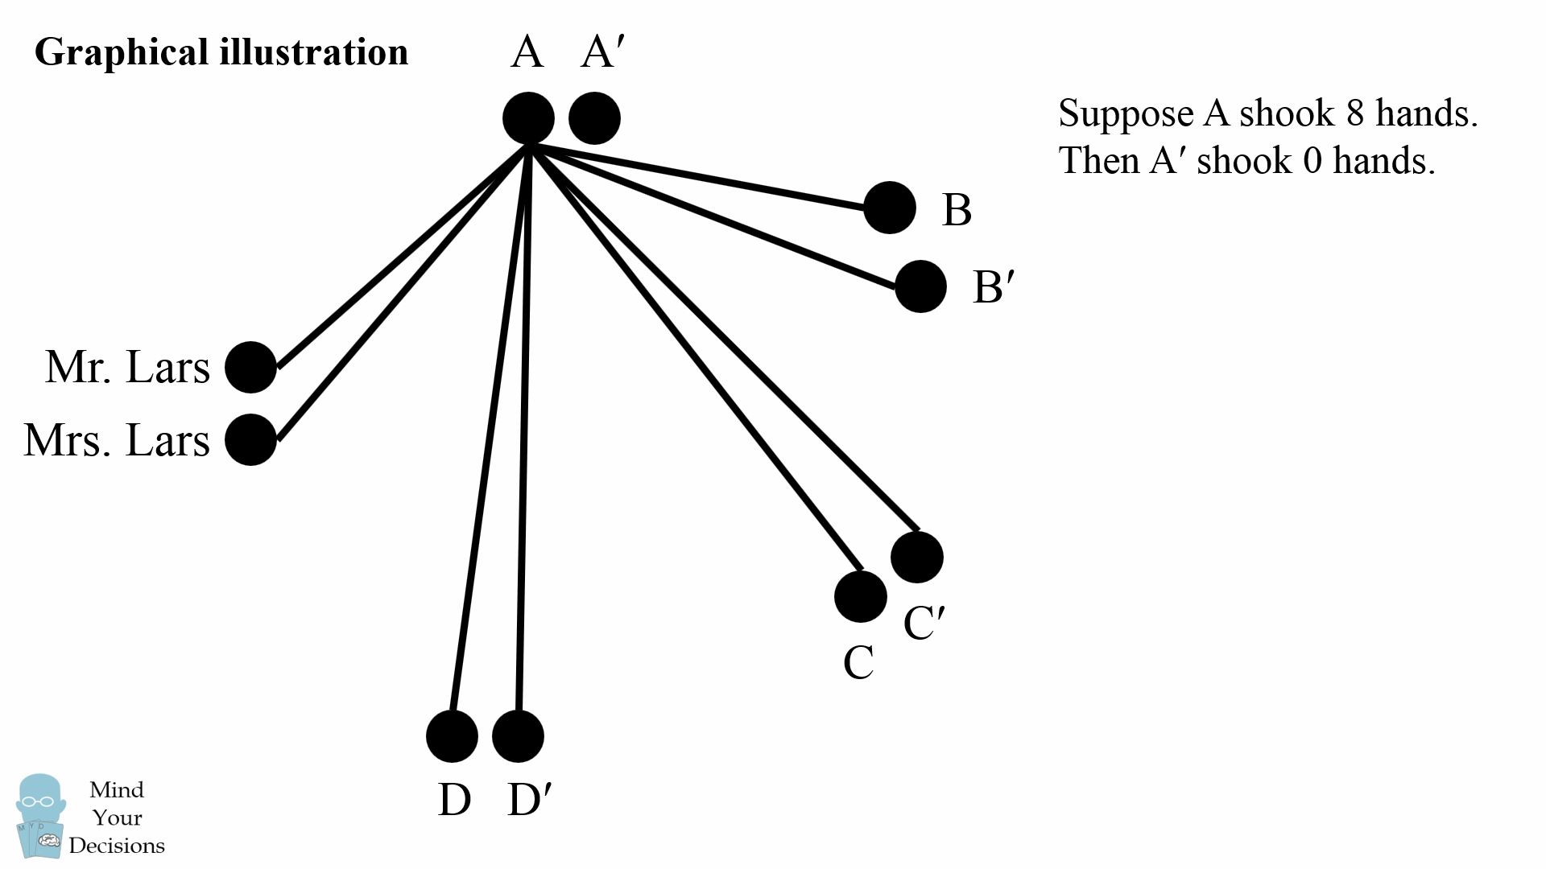

From this graph, there is only one point not connected by an edge, the spouse of the person who answered 8. This is the only possible choice for the person who answered 0. Thus the answers of 8 and 0 are coupled.

Now someone else answered 7, suppose that is B. In every other couple, each person is already connected by 1 edge. Now take some point and draw 6 more edges. This will connect to everyone in the group except the spouse of that point.

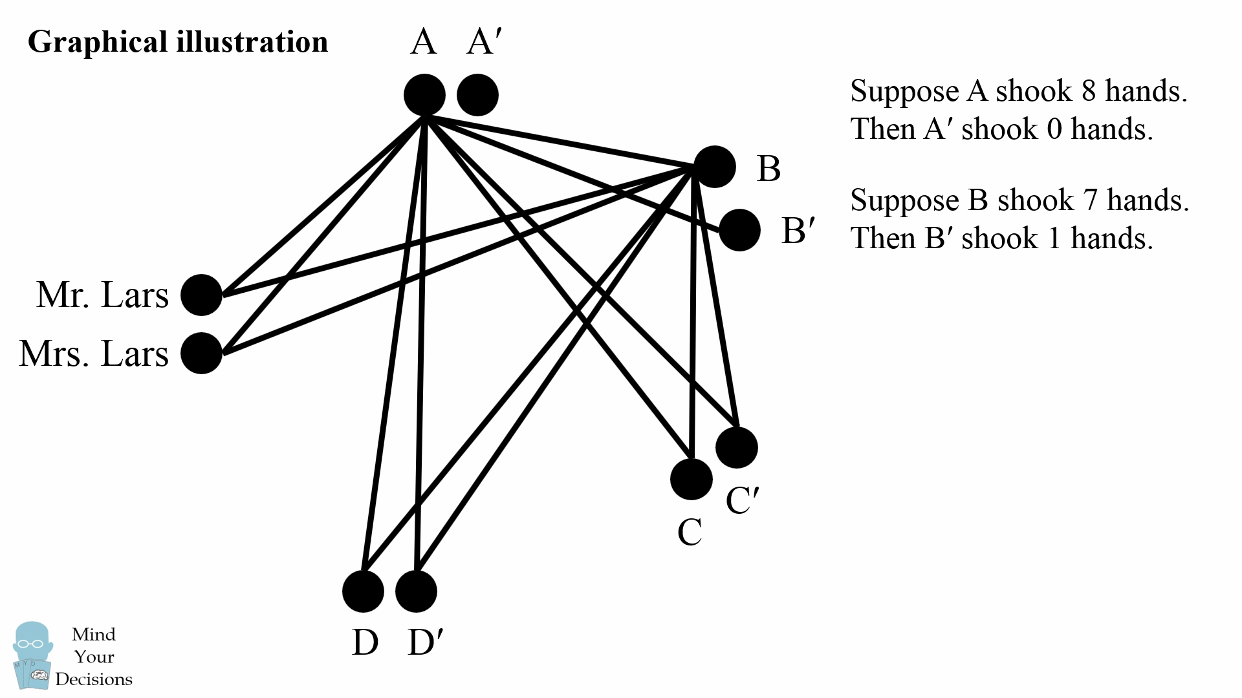

From this graph, there is only one point not identified already or connected by 2 edges, and that is the spouse of the person who answered 7. This is the only possible choice for the person who answered 1. Thus the answers of 7 and 1 are coupled.

We can continue the logic to find that the answers of 6 and 2, as well as the answers of 5 and 3 are coupled. Here are the graphs for those steps.

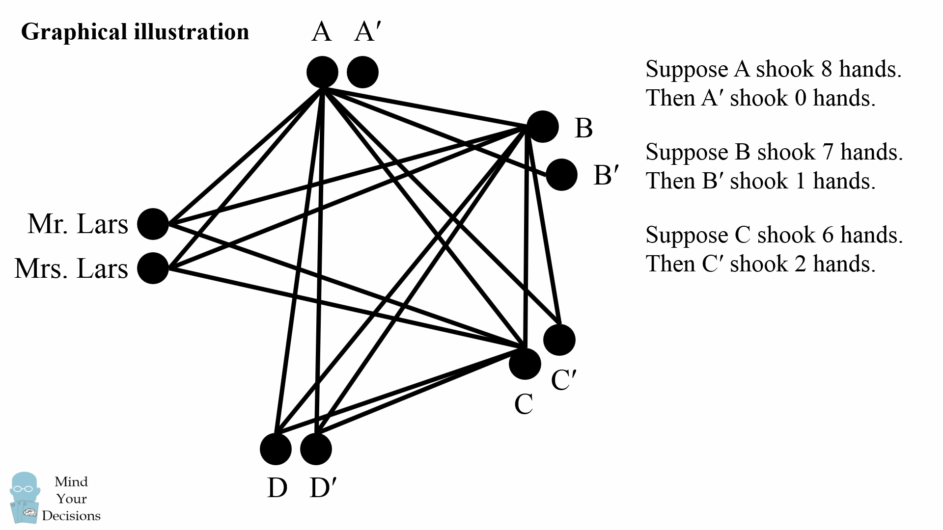

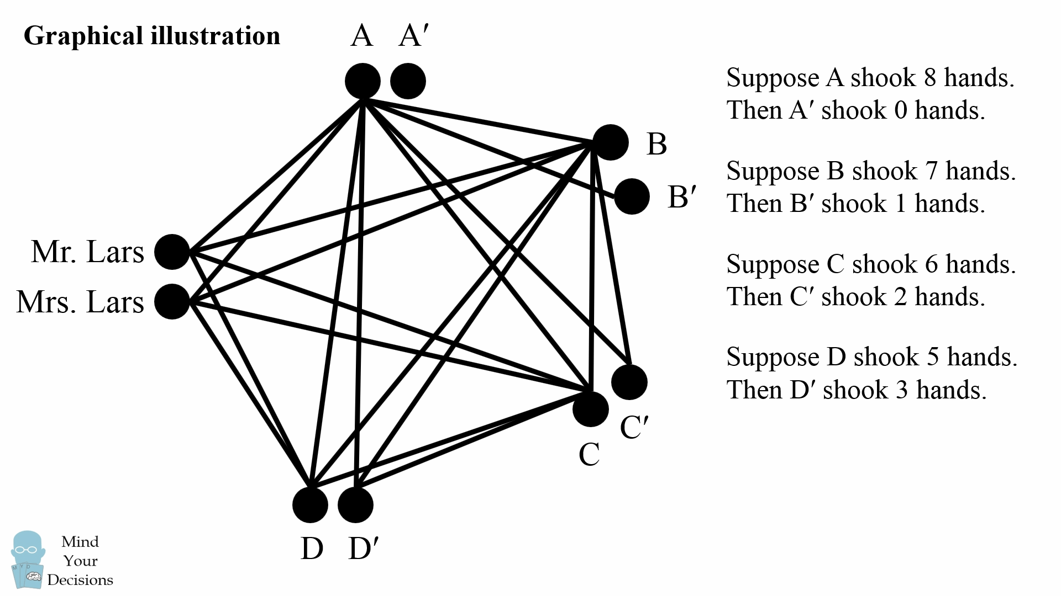

From the graph, we can see Mrs. and Mr. Lars both have 4 edges, so each of them shook hands with exactly 4 people.

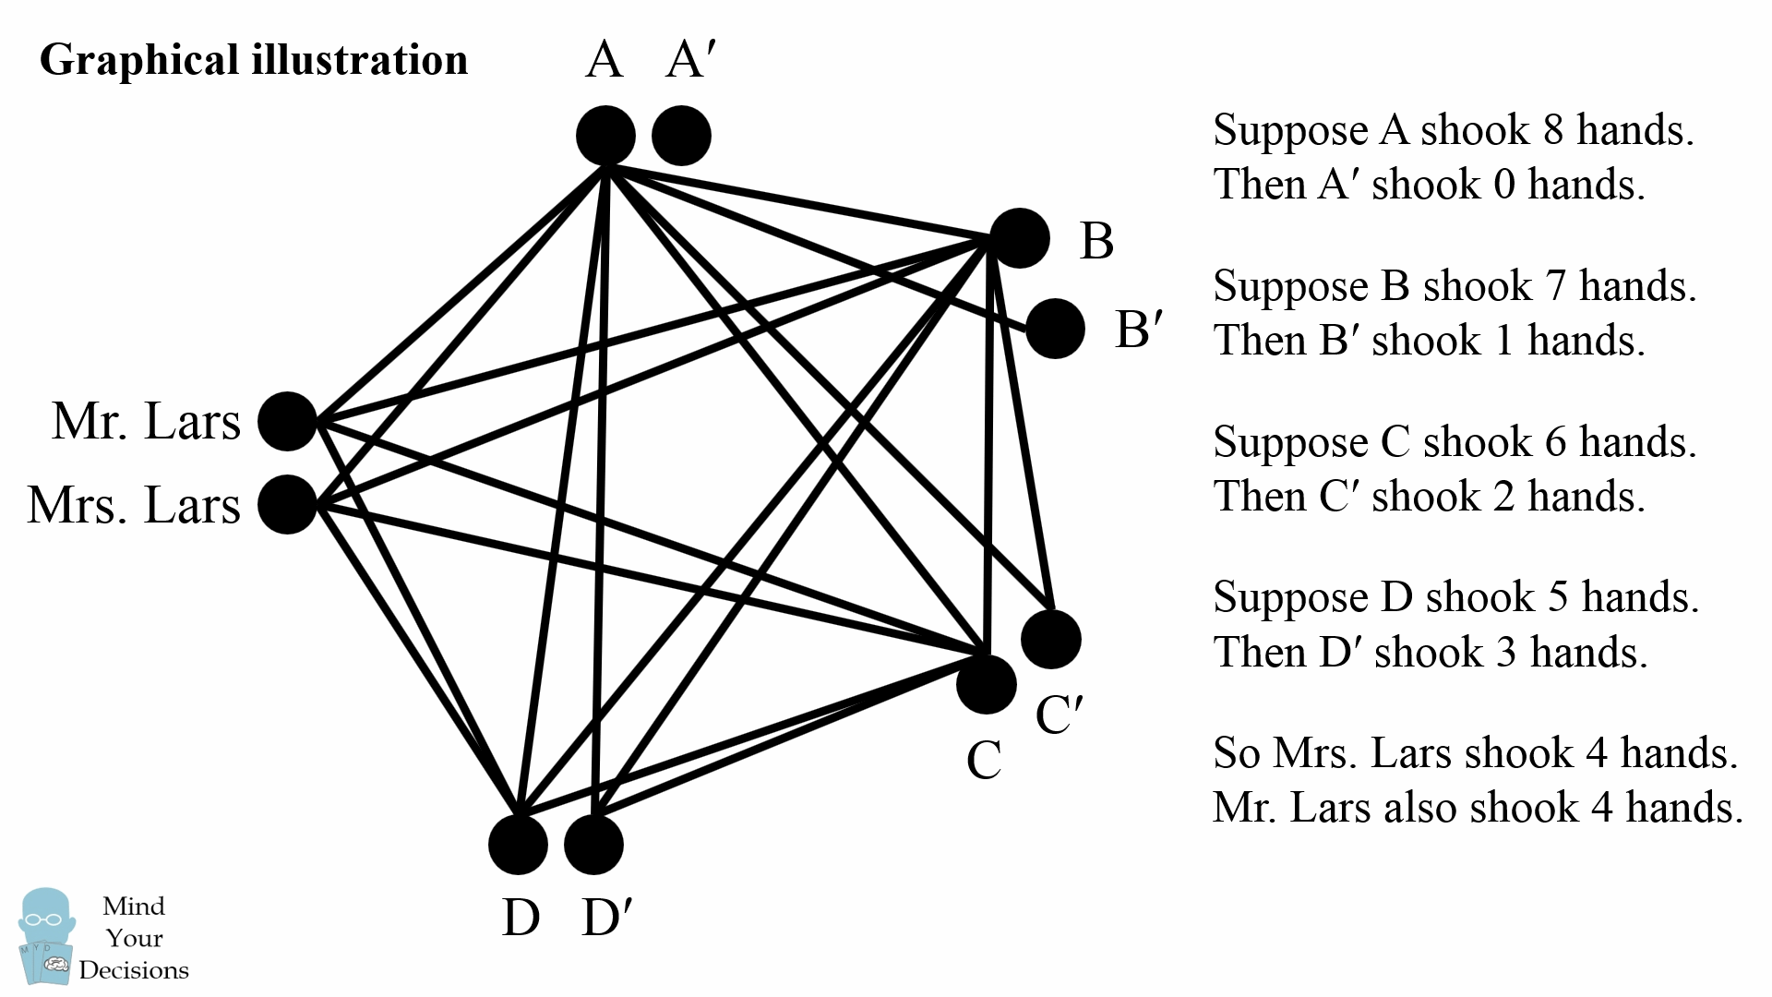

Amazingly we could solve this puzzle by careful logical reasoning!